Kinematics Review Quiz Multiple Choice Questions

1. Which of the following are VECTOR quantities?
I. position II. speed III. displacement IV. velocity
a. I and III only d. II, III and IV only
b. III and IV only e. I, III and IV only
c. I and IV only

2. Two hikers set out from the same spot and arrive at the same destination but they take different routes. Which of the following quantities must be the same for both hikers?
a. | distance | d. | average speed
b. | displacement | e. | acceleration
c. | average velocity

3. Which of the following graph(s) does(do) NOT represent uniform motion?
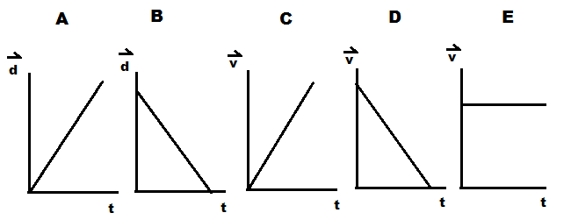

a. | A,B,C and D | d. | A and B
b. | B only | e. | C and D
c. | E only

4. The slope of a line drawn tangent to a curved position-time graph represents
a. | displacement | d. | acceleration
b. | instantaneous velocity | e. | distance
c. | average velocity

5. An object is travelling west and slowing down. The directions associated with the
object’s velocity and acceleration, respectively, are:
a. [W], [W] b. [W], [S] c. [W], [E] d. [E], [W] e. [E], [S]

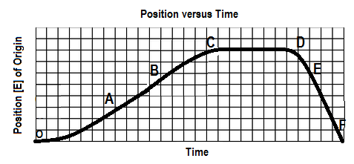
6. The graph below shows a position-time graph

Over which interval is the object moving west and speeding up?
a. OA b. BC c.CD d. DE e.EF

7. The area under a velocity-time graph represents
a. | displacement | d. | instantaneous velocity
b. | acceleration | e. | average velocity
c. | change in velocity

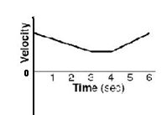
8. A velocity-time graph is shown at right. Which of following best
describes the object’s motion? The object

a. moves backward at a constant velocity, stops, then moves forward at constant velocity.
b. moves forward at a constant velocity, stops, then moves backward at constant velocity
c. slows down uniformly as it moves backward, stops, then speeds up uniformly as it moves forward
d. slows down uniformly as it moves forward, continues at a constant velocity forward, then speeds up
uniformly as it continues to move forward
e. slows down uniformly as it moves backward, continues at a constant velocity backward, then speeds
up uniformly as it moves forward

SPH4U0-Sept. 11/2013 Kinematics Review Quest-VERSION B Name:_________________
Total: _________/37 marks [K/U]
Useful Equations and Constants:

Acceleration due to gravity on Earth: 9.80 m/s² [down]

v_{av} =ΔΔ a = ΔΔ = Δ Δd= ½ (v₁+v₂) Δt Δd=v₂ Δt – ½ a (Δt)²

Δd=v₁ Δt + ½ a (Δt)² Δd = $\frac{v22-v12}{2a}$ $x=\frac{-b±\sqrt{b^{2}-4ac}}{2a}$

Part A: Multiple Choice Answers [ 8 marks]:
Write the letter representing the best answer for each question in the table below:
1 | 2 | 3 | 4 | 5 | 6 | 7 | 8

Part B: Short Answer [ 4 marks]:

1.With the aid of two specific examples, explain the difference between uniform and non-uniform motion. [2]

2. On a training run for the LASS Terry Fox Run on Saturday, you leave your house to run 2.0 km North and then turn around to run 2.0 km South. The entire run takes you 25.0 minutes. When you check your GPS Garmin Running watch, you discover that our average velocity is 0.0 km/h. Is your watch broken? Explain. [2]

Part C: Graph Analysis [8 marks]

1. The motion of a train engine moving along a straight track in a railyard is shown on the velocity-time
graph below.
i) Draw the corresponding acceleration-tine graph for the train. [3]
ii) Assuming that the train starts at the station (origin), draw the corresponding
position-time graph. [5]

Position-Time Graph:

Velocity-Time Graph:
8

4

0

-4

-8

V
(m/s)

[E]
Time
(s)
 | 1.0 |  | 2.0 |  | 3.0 |  | 4.0 |  | 5.0 |  | 6.0 |  | 7.0 |  | 8.0 |  | 9.0 |  | 10.0

Acceleration-Time Graph:

Part D: Problem Solving [ 16 marks]

1. Sonic the Hedgehog is sitting at rest one day when Big the Cat runs by at a constant velocity of 7.50 m/s [Forward]. Sonic decides to chase Big and immediately takes off from rest with an acceleration of 3.25 m/s² [Forward]. Determine the time and displacement from his starting position at which Sonic catches up with Big. [6]

Graph Analysis Calculations:

2. A LASS volleyball player receives a hard serve by volleying the ball straight up into the air with an initial velocity of 15.0 m/s [up]. The ball rises up and strikes an overhead light located 10.0 m above the player’s head.
a) Find the ball's velocity just as it hits the light. [3]
b) Find the time the ball was in the air. [3]

3. A train leaving the Brampton Go station accelerates uniformly from rest for 2.0 minutes to reach of velocity of 80.0 km/h [East] and travels at this velocity for 5.0 minutes. It then slows down as it enters a residential zone by accelerating uniformly for 2.0 minutes to reach a velocity of 40.0 km/h West. The train proceeds at this new velocity of another 5.0 minutes.
a) Sketch the velocity-time and position-time graphs for the motion of the train assuming the origin is the Brampton Go Station. (Although no scales are required, the time scales of the two graphs should correspond). [3]

$\vec{v}$
[East]

$$\overset{→}{d}$$
[East]

b) Briefly explain the analysis you would perform to find the total displacement of the train over the trip described. (No calculations are required). [2]

